[Array 19 (2023) 100317](https://doi.org/10.1016/j.array.2023.100317)

|  |  |  |
| --- | --- | --- |
|  | Contents lists available at [ScienceDirect](https://www.elsevier.com/locate/array) |  |
| Array |
| journal homepage: [www.elsevier.com/locate/array](http://www.elsevier.com/locate/array) |
|  | | |

A comprehensive framework for hand gesture recognition using hybrid-metaheuristic algorithms and deep learning models

Hassan Mohyuddina, Syed Kumayl Raza Moosavib, Muhammad Hamza Zafarc, Filippo Sanfilippoc,d,∗

a *Department of Electrical Engineering, Capital University of Sciences and Technology, Islamabad 44000, Pakistan*   
b *School of Electrical Engineering and Computer Science, National University of Sciences and Technology, Islamabad 44000, Pakistan* c *Department of Engineering Sciences, University of Agder, Grimstad 4879, Norway*   
d *Department of Software Engineering, Kaunas University of Technology, Kaunas 51368, Lithuania*

|  |  |  |
| --- | --- | --- |
| A R T I C L E | I N F O | A B S T R A C T |
| *Keywords:*  Feature selection  Dimensional reduction  Big data  Meta heuristic algorithms Machine learning | | This paper presents a novel methodology that utilizes gesture recognition data, which are collected with a Leap Motion Controller (LMC), in tandem with the Spotted Hyena-based Chimp Optimization Algorithm (SSC) for feature selection and training of deep neural networks (DNNs). An expansive tabular database was created using the LMC for eight distinct gestures and the SSC algorithm was used for discerning and selecting salient features. This refined feature subset is then utilized in the subsequent training of a DNN model. A comprehensive comparative analysis is conducted to evaluate the performance of the SSC algorithm in comparison with established optimization techniques, such as Particle Swarm Optimization(PSO), Grey Wolf Optimizer(GWO), and Sine Cosine Algorithm(SCA), specifically in the context of feature selection. The empirical findings decisively establish the efficacy of the SSC algorithm, consistently achieving a high accuracy rate of 98% in the domain of gesture recognition tasks. The feature selection approach proposed emphasizes its intrinsic capacity to enhance not only the accuracy of gesture recognition systems and its wider suitability across diverse domains that require sophisticated feature extraction techniques. |

**1. Introduction**

Big data analytics is one of the key areas where the next generation of parallel and distributed systems will be used. Nowadays, exabyte-sized data repositories for these applications exist and are growing quickly. These datasets, in addition to their sheer size, provide major obstacles to techniques and software development. The volume and security concerns of datasets, which are frequently dispersed, call for distributed methods using platforms used to store data frequently have a wide range of computing and networking capabilities. Many appli-cations require careful consideration to fault-tolerance, security, and access control [1]. Analysis tasks often come with tight deadlines, and in certain cases, ensuring high-quality data is a significant challenge. Data-driven models and techniques that can function at scale are yet unknown for most developing applications.

The term ‘‘Big Data’’ encompasses not only the immense volume of data but also its intricate complexity and diverse variety [2], and velocity [3]. The advent of big data has revolutionized organizational operations and decision-making processes [4]. Through the utilization of advanced big data analytical tools and technologies, organizations

can harness valuable insights into customer behavior, market trends, and operational performance. These insights enable informed decision-making, drive efficiency enhancements, and foster innovation within the organization [4]. But the sheer volume of data alone cannot better systems, it is not just the quantity of data but also its quality that affects the output of a system [5]. The presence of poor-quality data can have detrimental effects on decision-making and business operations, as it may result in inaccurate and unreliable outcomes. Such consequences can significantly impact the organization’s effectiveness and success. Therefore, ensuring data quality is of utmost importance to mitigate risks and make sound decisions based on trustworthy information [6]. Therefore, good quality data is an empirical part of modern technology and it is being used everywhere from using machine learning (ML) al-gorithms to redefine healthcare and make more accurate diagnoses [7] to its use in reshaping our modern-day financial decisions [8].

Human action recognition is also an area that has become increas-ingly popular in the pattern recognition and computer vision areas as a consequence of the expansion of numerous interactive applications in human–computer interaction. Hand gesture detection (HGD) is used

∗ Corresponding a[uthor at: Department of](mailto:filippo.sanfilippo@uia.no) Engineering Sciences, University of Agder, Grimstad 4879, Norway. *E-mail address:* [filippo.sanfilippo@uia.no](mailto:filippo.sanfilippo@uia.no) (F. Sanfilippo).

<https://doi.org/10.1016/j.array.2023.100317>  
[Received 18 June 2023; Received in revised](https://doi.org/10.1016/j.array.2023.100317) form 20 August 2023; Accepted 27 August 2023 Available online 1 September 2023

2590-0056/© 2023 The Author(s). Published by Elsevier Inc. This is an open access article under the CC BY license (<http://creativecommons.org/licenses/by/4.0/>).

*H. Mohyuddin et al.*  *Array 19 (2023) 100317*

in a variety of applications gaming, virtual reality, and healthcare to perform critical operational procedures. Using gestures to control a computer or a smart device, or enable a virtual character to mimic the movements of a user in a virtual reality environment would remove the requirement for an intermediate input device between humans and computers and users will be able to control machines with mere gestures [9]. Two main methods are being used for HGD, namely Static HGD and Dynamic HGD. Static HGD means the detection of still gestures whereas Dynamic HGD covers motion-based gestures. Over the years, researchers have developed a variety of ways for HGD including wearable technology-based, depth-based [10], and vision-based detection [11]. While wearable gloves can accelerate the process, it is important to note that the underlying technology can be costly and does not always ensure reliable outcomes. On the other hand, the availability of cheap but efficient sensors has played its part in the evolution of this field. Sensors like the Microsoft Kinect, Intel Realsense, and Sensz3D provide depth and color information, while the Leap Motion Sensor (LMC), employed in this study, captures short IR images and provides data regarding the skeletal information of the hand. The data can either is captured visually or it can be tabulated from the sensor data [12–14].

Another method, found in literature, is to use raw data directly and apply ML algorithms to identify gestures. This method has been dis-cussed in [15] using the Deep Learning technique on more than 30000 features and in [16] using the k-nearest neighbors algorithm (KNN), Decision Trees, and support vector machines (SVM). The advantage of using raw data is that it is faster than the conventional algorithms used for image detection and with large enough data the efficiency could be improved greatly. However, not all features extracted from the sensor are useful and it is hard to go through each feature and find those that give the best results. In this regard, using feature selection techniques can narrow down the data set to the specific features which give the best results [17].

Feature selection (FS) is being used in a variety of applications for the process of reducing data sets without compromising on the efficiency of the system and in most cases even enhancing the perfor-mance as well by removing redundant features [9,18]. Dimensionality reduction using feature selection methods can be achieved in a va-riety of ways including selection based on statistical properties and correlations (Filter based methods) [19], using conventional techniques such as PCA [20] or LDA [21] and using Wrapper based methods. However, there is a new range of algorithms which, over the years have proven to be more effective in solving this problem for complex data sets, these are called metaheuristic algorithms. Metaheuristic al-gorithms have been widely used in feature selection to derive optimal feature subsets. These algorithms are renowned for their capability to discover the optimal solution within expansive feature spaces. They are commonly employed in optimization problems characterized by intricate search spaces and non-linear objective functions. Their ef-fectiveness in navigating complex landscapes makes them valuable tools for tackling challenging optimization tasks. These are inspired by natural processes, such as evolution, hunting, movement, or foraging behavior of different organisms. Several bio-inspired meta-heuristic algorithms are commonly used in various optimization problems. Some of the most well-known bio-inspired meta-heuristic algorithms include Particle Swarm Optimization (PSO), Genetic Algorithm (GA), Artificial Bee Colony (ABC) Optimization, Firefly Algorithm (FA), Grey Wolf Optimization (GWO), and Whale Optimization Algorithm (WOA). Each of these algorithms is inspired by different biological phenomena, such as swarming behavior, evolution, migration, hunting, and foraging. The LMC from Ultraleap is an optical hand-tracking device. It is primarily intended for use in interactive software applications for hand gesture and finger position recognition [22]. It records the motion of the user’s hands and fingers to enable natural interaction with the digital content and has been widely used for gesture detection in various applications, including:

2

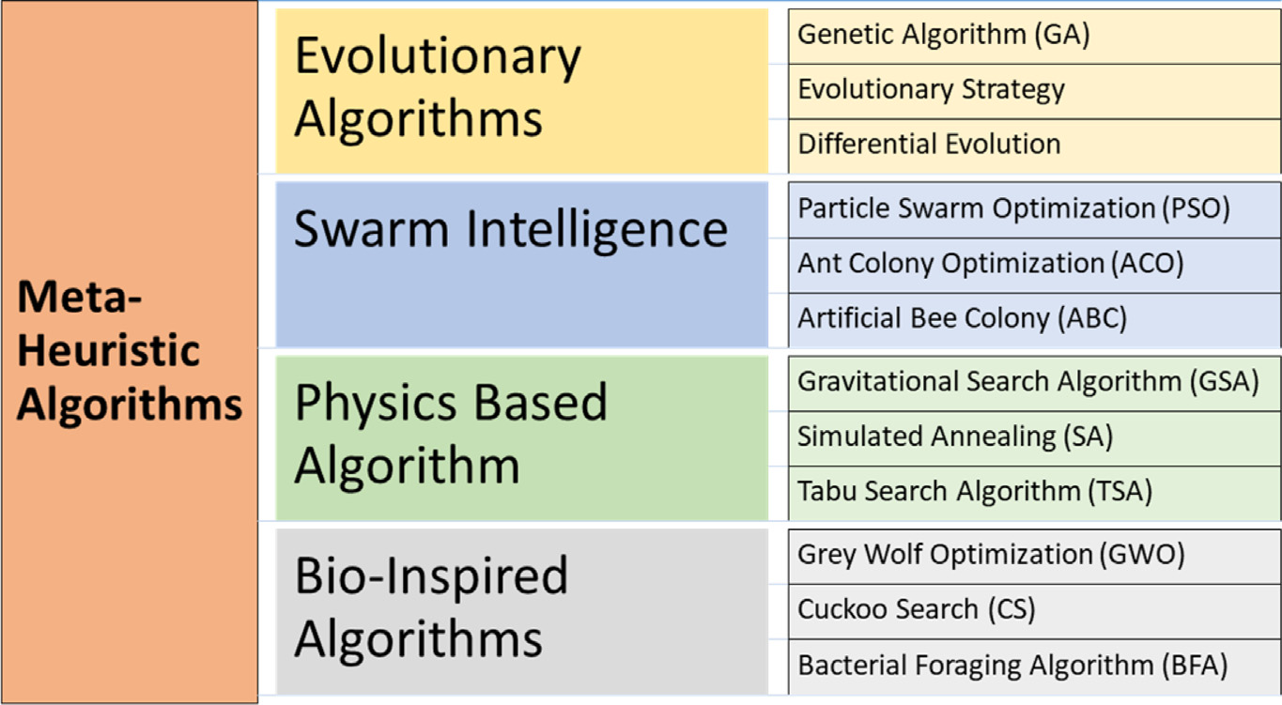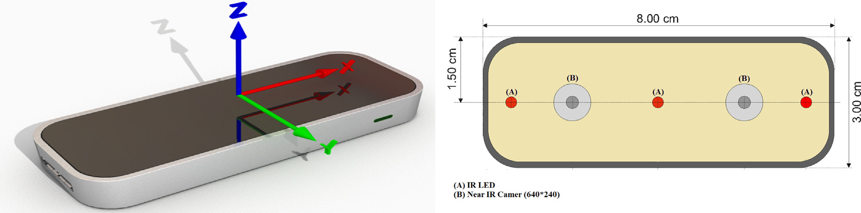

*H. Mohyuddin et al.*  *Array 19 (2023) 100317*

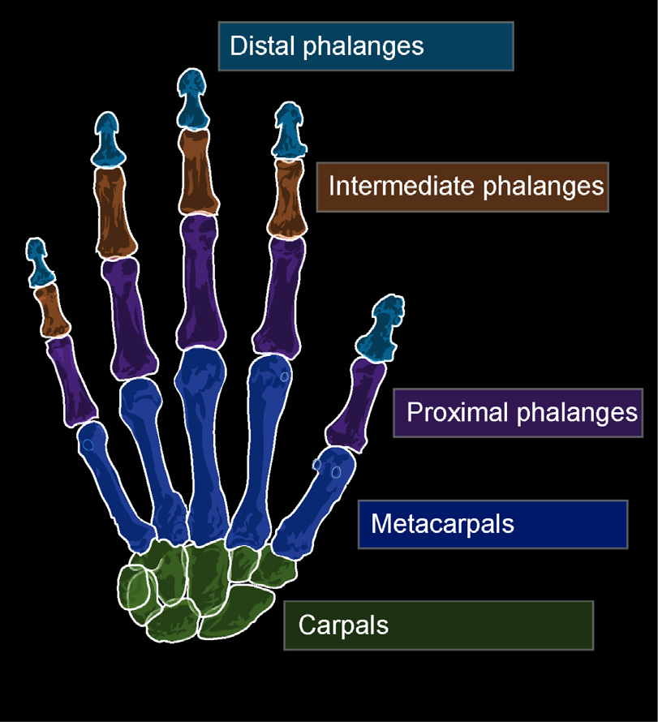

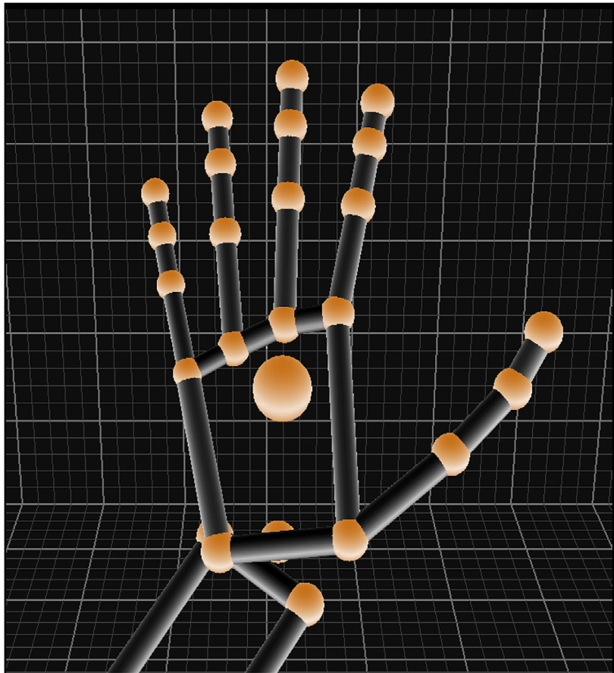

 

**Fig. 1.** Human Hand visualization using the LMC.

**Fig. 2.** LMC Schematic Diagram [27].

**Fig. 3.** Brief Classification of Meta-Heuristic Algorithms.

the population so the solution(mutation) does not get stuck on local minima. The ability of these algorithms to deal with large dataset and complex real-world problems make them an ideal candidate for the purpose of dimensionality reduction.

In this paper, a dataset is developed containing eight static fea-tures using the LMC. The dataset is then pre-processed and passed through a metaheuristic algorithm. The first step is to use a hybrid

3

*H. Mohyuddin et al.*  *Array 19 (2023) 100317*

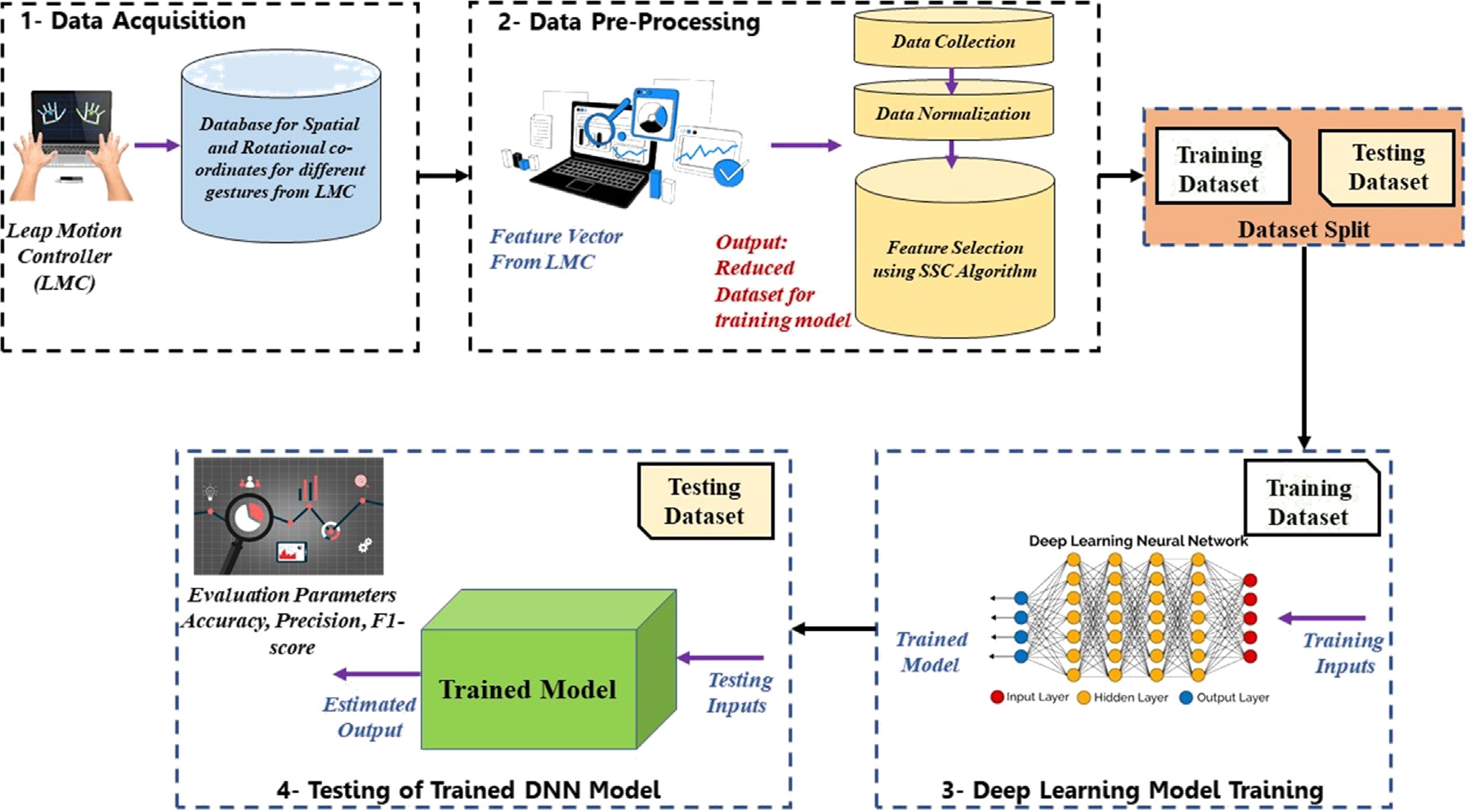

**Fig. 4.** Proposed scheme of study for the proposed technique.

datasets. The results compiled show that reducing the dataset reduces the number of parameters to be trained and the complexity of the DNN without compromising the overall efficiency of the system. A detailed figure of the scheme developed during the course of this paper is shown in Fig. 4.

*1.1. Contribution and paper organization*

The contributions of this work are:

• Creation of a new hand gesture dataset that can potentially be used for future research in hand gesture recognition.

• Development of a novel metaheuristic algorithm (SSA) for feature extraction from a hand gesture dataset collected using the LMC.• Comparison of the performance of the proposed metaheuristic al- gorithm with other state-of-the-art algorithms i.e. PSO, GWO and SCA for feature extraction from hand gesture data is evaluated.• Development of a hybrid deep learning model (SSA-DNN) that integrates the proposed metaheuristic algorithm for feature ex- traction is formulated. The model can achieve better performance with selected and full features.

• The proposed methodology and experimental setup can poten-tially serve as a framework for other researchers interested in developing hand gesture recognition models.

The remainder of the paper is composed as follows. Section 2 discusses recent related work. In Section 3 details about the dataset generation and pre-processing is described. Section 4 highlights the details of the proposed technique for feature selection. Section 5 discusses the proposed technique for classification and Section 6 covers results and discussion of the experiment.

**2. Related work**

Metaheuristics have been the center for research in computing and optimization problems for the past few decades. GWO, ABC, PSO, and WOA are among some of the most widely used nature-inspired algo-rithms for solving complex real-world problems. PSO is a population-based algorithm derived from the collective movement of a flock of birds or a school of fish. It employs a swarm of particles to search for the best solution by adjusting their speed and position relative to

4

|  |  |  |  |  |  |  |  |  |  |  |
| --- | --- | --- | --- | --- | --- | --- | --- | --- | --- | --- |
| *H. Mohyuddin et al.* | **Table 1**  Data extracted from the LMC. | | |  |  |  |  |  |  | *Array 19 (2023) 100317* |
|  | Gesture | Hand | PalmX | H_Roll | H_Yaw | Arm_DirX | Wrst_Pos_Z | EL_Pos_X | EL_Pos_Y |  |
|  | 1  2  3  4  5  6  7  8 | R  R  R  L  R  R  L  R | 10.92  132.8  20.00 −4.63  2.24 −1.27  7.21 −33.41 | −8.24  145.16−9.68 −9.20 −0.97  8.35  66.96  81.07 | −0.31  44.97 −58.91 4.75 −5.88 −17.75−11.15 4.21 | −0.27  0.86 −0.92  0.015 −0.58  0.67 −0.44  0.16 | 123.45  99.03  57.37  134.67  97.34  108.03  96.33  68.42 | 93.59 −157.31 338.81 −20.77  182.98 −166.58 141.36 −87.66 | 224.07  43.55  152.56  319.30  171.45  30.61  250.18  233.00 |  |

recall, and F-measure metrics. In [15], the authors presented a HGR system using LMC and DNN. The system reconstructed the palm model and extracted the feature data from LMC. The system trains the DNN model with the normalized data to achieve good gesture recognition accuracy. For the dataset, 30 features were captured from the LMC mainly focusing on the spatial positioning of the palm and bones. The paper focused on the classification of three gestures by employing static feature selection and classification using a DNN model.

**3. Experimental setup**

For this experiment the LMC was mounted on a jig to keep the posi-tion static. The data was collected under controlled lighting conditions throughout the experiment as IR sensors are sensitive to light. During the course of the experiment, data was collected with varying distances ranging from 100 mm to 300 mm to add variation in scale. The LMC was integrated with the system using LEAPSDK v2.0 and python 2.7 on a Hp core i3-10th generation Intel micro-processor and no GPU. The data set was collected and stored as .csv file. This data was then imported to Python 3 and pre-processed using a variance-based method for initial scrutiny of the feature set. After the first pre-processing the data was normalized and passed through the feature selection and classification algorithms.

*3.1. Dataset generation*

Data for eight static hand gestures was recorded for both left and right hands with 16 participants. A mixed variety of participants was included from different age groups and genders to introduce variation in scale. Data was recorded at different heights for both Left and Right hands and some gestures were skewed intentionally to introduce vari-ation in orientation to cater to different real-world scenarios. Previous datasets available online use pictorial representation however, for the purpose of this paper tabular data is collected to train the proposed model. The LMC gives 210 feature points for each sample point. A sample of entry for each class is shown in Table 1. Out of these only 19 features were dropped due to negligible variance. The dataset contains positional and rotational data for the wrist and palm. The sensor also gives the position of four bones(meta-carpel, proximal, intermediate, and distal) of each finger. A total of 264 sample points were collected for five labels. Some of the feature points are shown in Fig. 5. To further improve model performance data was normalized to create a uniform distribution. It was observed that the model gave good and consistent results when using normalized data. Table 1 displays several data points. Fig. 6 shows the correlation of data points plotted between different features against gesture classes. It is evident that simply choosing random features will not help in designing a good model for gesture detection as the data points are not distributed distinctly.

*3.2. Dataset pre-processing*

Data pre-processing in this case mainly comprises data normaliza-tion. The minima and maxima of each feature are extracted and data is normalized as per (1). The raw data from the LMC includes information

5

*H. Mohyuddin et al.*  *Array 19 (2023) 100317*

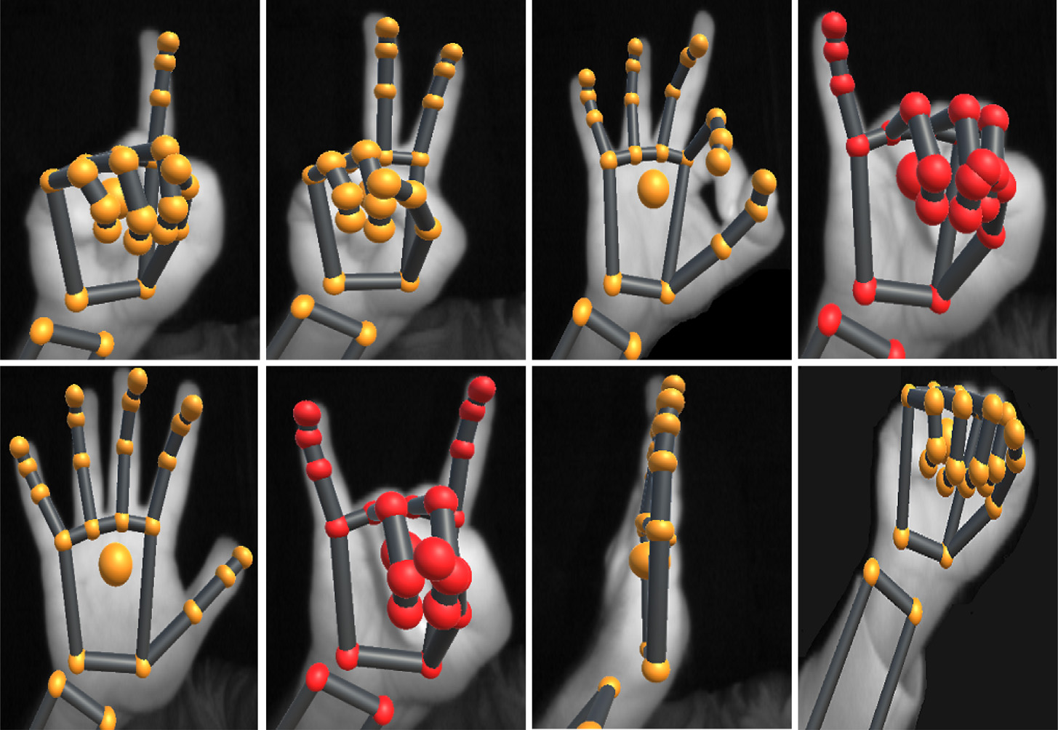

**Fig. 5.** Gestures used for detection.

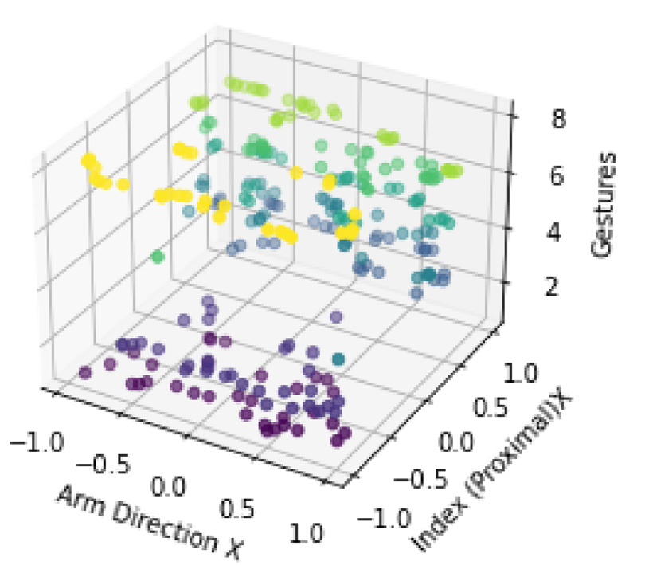



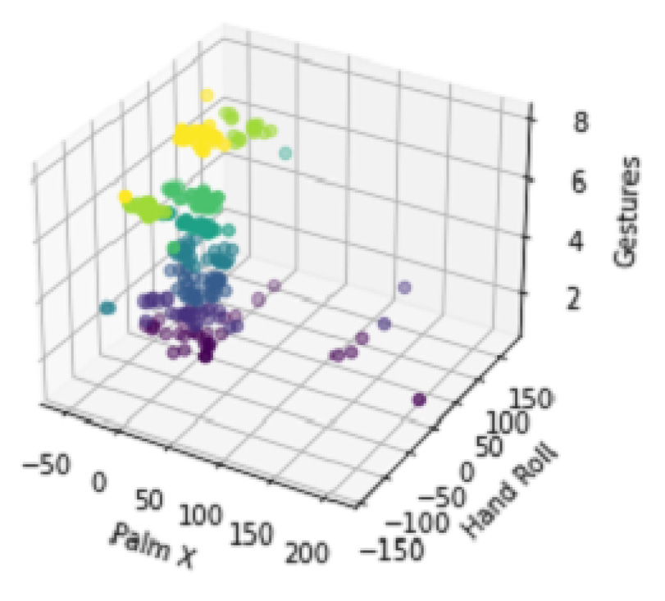



**Fig. 6.** Correlation sample between different features on the *𝑥* and *𝑦* axis vs. Gesture classes on the *𝑧*-axis.

|  |  |  |  |
| --- | --- | --- | --- |
| *4.1. SSC metaheuristic algorithm* | 6 | the population towards or away from the optimal solution. By intro-ducing the randomness based on these oscillatory functions this system has shown promising results to tackle the local optima problem. The solution update mechanism for the algorithm is depicted as: | |
| As discussed in Section 1.1, the dataset developed for gesture de-tection contains 191 features. Solving a classification problem for such a dataset using conventional methods will not yield useful results. The hybrid algorithm, SSC [55], used is based on the Sine-Cosine Algorithm (SCA) [56], Spotted Hyena Optimizer (SHO) [57] and Chimp Optimization Algorithm (ChOA) [58]. The algorithm is inspired by the sexual attraction of chimps and the exploration of spotted hyenas. The sine-cosine algorithm has been used to introduce randomness in order to solve the local minima problem. The initialization process of ChOA along with the attacking strategy of SHO and update rule as per SCA has shown good results as compared to the individual algorithms. The use of SCA helps to avoid local minima while the ChOA widens the search space for better global minima tracking. |
| *𝜁𝑘*+1 *𝑖*  = *𝜁𝑘*  *𝑖*− *𝜉𝑡*  (2)  *𝜁𝑘*+1 *𝑖*  = *𝜁𝑘 𝑖*+ (*𝑅*1∗ *𝑠𝑖𝑛*(*𝑅*2) ∗ |*𝑅*3*.𝜁𝑘 𝑖*− *𝜉𝑡 𝑖*|) (3)  where *𝜁𝑘*  *𝑅*1*, 𝑅*2*, 𝑅*3 are random numbers and *𝜉𝑡*  *𝑖*is the current position in *𝑖*th dimension at *𝑘*th iteration and *𝑖*+ (*𝑅*1∗ *𝑐𝑜𝑠*(*𝑅*2) ∗ |*𝑅*3*.𝜁𝑘*  *𝑖*|) *𝑖*is the solution for *𝑖*th iteration and *𝑘*th population. A graphical representation of SCA is given in Fig. 7. | |
| *4.1.2. Spotted hyena algorithm*   The spotted hyena algorithm is based on social activity and the relation between hyenas. It mainly focuses on the attacking, encircling, hunting, and searching behavior of hyenas. SHO mimics the activity of spotted hyenas to achieve an optimum solution. Encircling can be depicted by the following two equations. | |
| *4.1.1. Sine-cosine algorithm*   SCA was originally presented by Mirjalili in [59], the algorithm utilizes the mathematical model of sine-cosine functions to fluctuate |
| *𝜁ℎ* = |*𝐴.⃖⃖⃗𝜉𝑝*(*𝑥*) −*⃖⃗𝜉*(*𝑥*)| | (4) |

*H. Mohyuddin et al.*  *Array 19 (2023) 100317*

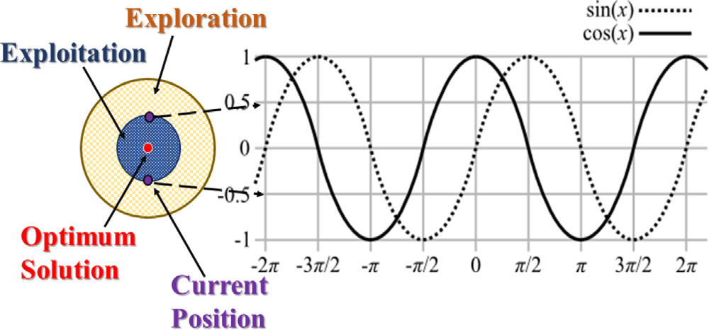

**Fig. 7.** Metaheuristic: Sine-Cosine Optimization Algorithm.

*⃖⃗𝜉*(*𝑥* + 1) = *⃖⃖⃗𝜉𝑝*(*𝑥*) − *𝐵.⃖⃖⃖⃗* (5)

where *𝜉𝑝* show the optimum feature vector (FV), *𝜉*(*𝑥*) is the current FV and *𝜁ℎ* shows the distance that the corresponding hyena would have to travel to catch its prey. The coefficients *𝐴* and *𝐵* are calculated using

the following equations

*𝐴* = 2*.𝑑*1 (6)

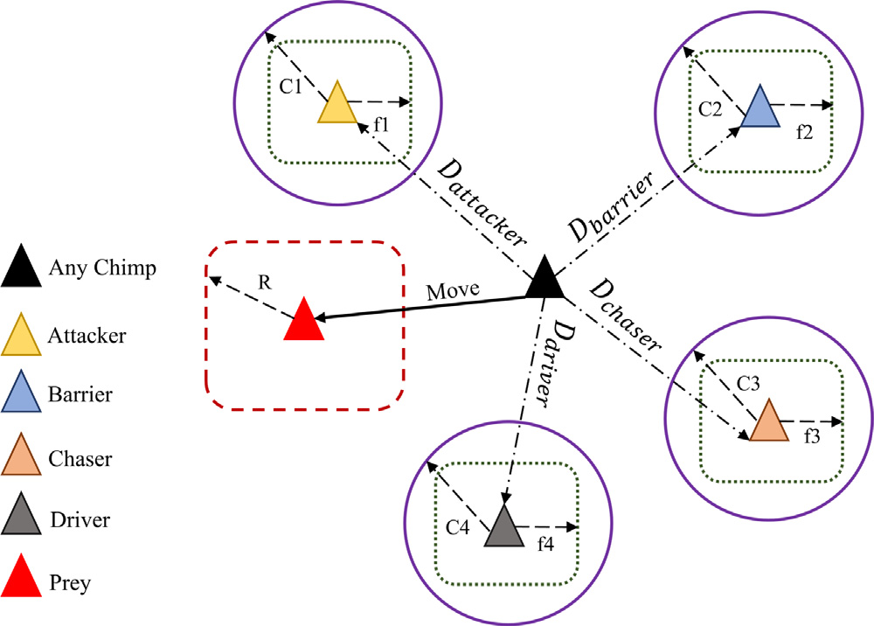

**Fig. 8.** Working mechanism of ChoA Algorithm.

*𝑥𝑐ℎ𝑖𝑚𝑝*(*𝑖* + 1) = *𝑥𝑝𝑟𝑒𝑦*(*𝑖*) − *𝛼.𝛽*  (15)

|  |  |  |  |  |  |
| --- | --- | --- | --- | --- | --- |
| *𝐵* = 2*.ℎ.𝑑*2 − *ℎ* | (7) | 7 | where *𝑖* is the number of current iterations, *𝑥𝑝𝑟𝑒𝑦* is the position of prey and *𝑥𝑐ℎ𝑖𝑚𝑝* is the chimp position. The vectors *𝛼*, *𝑚*, and *𝛾* can be calculated as: | | |
| *ℎ* = 5 −*𝑘𝑡ℎ* ∗ 5 (8) *𝑚𝑎𝑥𝑘*  here, the value *𝑘*th is the value of current iteration and *𝑚𝑎𝑥𝑘* is the maximum number of iterations. The vector h is reduced from 5 to 0, as  shown in (8), and *𝑑*1 and *𝑑*2 are random numbers within the range of [0*,* 1]. Following equations map the hunting regions of spotted hyenas: | |
| *𝛼* = 2*.𝑓.𝑟*1 − *𝑓* | | (16) |
| *𝛾* = 2*.𝑟*2 | | (17) |
| During the iterative process the coefficient *𝑓* is reduced form 2.5 to 0, *𝑟*1. and *𝑟*2 are random values in the range [0,1]. The attacking model of chimps can be described by the following equations. | | |
| *𝜁ℎ* = |*𝐴* ∗*⃖⃖⃖⃗𝜉ℎ* − *𝐵* ∗*⃖⃖⃖⃗𝜉𝑘*|   *𝜉ℎ* −*⃖⃖⃖⃗* | (9)  (10) |
| (18) *𝛿𝑎𝑡𝑡𝑎𝑐𝑘𝑒𝑟* = |*𝑐*1*.𝛼𝑎𝑡𝑡𝑎𝑐𝑘𝑒𝑟* − *𝑚*1*.𝑥*| (19) *𝛿𝑏𝑎𝑟𝑟𝑖𝑒𝑟* = |*𝑐*2*.𝛼𝑏𝑎𝑟𝑟𝑖𝑒𝑟* − *𝑚*2*.𝑥*| (20) *𝛿𝑐ℎ𝑎𝑠𝑒𝑟* = |*𝑐*3*.𝛼𝑐ℎ𝑎𝑠𝑒𝑟* − *𝑚*3*.𝑥*| (21) *𝛿𝑑𝑖𝑣𝑒𝑟* = |*𝑐*4*.𝛼𝑑𝑖𝑣𝑒𝑟* − *𝑚*4*.𝑥*| The initial chimps position is determined by the value of random  vectors. The chimp’s next position will be between its current position  and prey when the value is between the range [−1,1]. The update  strategy follows the following set of equations. | | |
| *𝑂ℎ* =*⃖⃖⃖⃗𝜁𝑘* +*⃖⃖⃖⃖⃖⃖⃖⃗𝜁𝑘*+1 + ⋯ +*⃖⃖⃖⃖⃖⃖⃖⃖⃗* | (11) |
| where*⃖⃖⃖⃗𝜉𝑘* shows the search space of the corresponding hyenas and*⃖⃖⃖⃖⃗*  shows the cluster of optimal solutions and *𝑁* is the number of iterations  which can be calculated as. | |
| *𝑁* = *𝑐𝑜𝑢𝑛𝑡𝑛*(*⃖⃖⃖⃗𝜁ℎ, ⃖⃖⃖⃖⃖⃖⃖⃗𝜁ℎ*+1*, ⃖⃖⃖⃖⃖⃖⃖⃗𝜁ℎ*+2*,* … *, ⃖⃖⃖⃖⃖⃖⃖⃖⃖⃗𝜁ℎ*+*𝑀*) | (12) |
| *⃖⃗𝜁*(*𝑥* + 1) = *𝑂ℎ⃖⃖⃖⃖⃗*  *𝑁*  (13)  where, *𝑛* is the number of solutions that are in a region close to the optimal solution. The vector*⃖⃖⃖⃗𝑀* shows a randomly initialized vector between [0*.*5*,* 1]. The best solution*⃖⃗𝜁*(*𝑥* + 1) helps in updating the remaining solutions at the end of each iteration. The exploration of the hyenas is ensured using the random coefficients *𝐴* and *𝐵* where the exploration starts when −1 *< 𝐵 <* 1 and *𝐴* ranges between [0*,* 5] and serves as a weight for the corresponding hyena. The optimization process begins with the initialization of a random population, each hyena marks its territory and with each iteration, the coefficients *ℎ* are decreased linearly. The best agents are then fetched after each iteration. | |
| *𝑥𝑛* = *𝛼𝑎𝑡𝑡𝑎𝑐𝑘𝑒𝑟* − *𝑎𝑛.𝛿𝑎𝑡𝑡𝑎𝑐𝑘𝑒𝑟* | | (22) |
| *𝑥*2 = *𝛼𝑏𝑎𝑟𝑟𝑖𝑒𝑟* − *𝑎*2*.𝛿𝑏𝑎𝑟𝑟𝑖𝑒𝑟* | | (23) |
| *𝑥*3 = *𝛼𝑐ℎ𝑎𝑠𝑒𝑟* − *𝑎*3*.𝛿𝑐ℎ𝑎𝑠𝑒𝑟* | | (24) |
| *𝑥*4 = *𝛼𝑑𝑖𝑣𝑒𝑟* − *𝑎*4*.𝛿𝑑𝑖𝑣𝑒𝑟* | | (25) |
| *4.1.3. Chimp optimization algorithm*   The Chimp Optimizer algorithm is a metaheuristic optimization algorithm inspired by the behavior of chimpanzees in their natural habitat. It mimics the social behavior of chimpanzees in a group, where each member of the group interacts with its peers to find the best solutions to a problem, as illustrated in Fig. 8. This technique was first developed by Khishe et al. in [58].  The mathematical model of ChoA is defined as follows | |
| *𝑥𝑡𝑖*+1 =*𝑥*1 + *𝑥*2 + *𝑥*3 + *𝑥*4 4 | | (26) |
| The following equation is applied to update each chimps position where the value *𝑚* is the chaotic value obtained randomly for each chimp and the distribution of *𝑚* can be chosen based on the optimization problem. | | |
| *𝛼𝑐ℎ𝑖𝑚𝑝*(*𝑛𝑖* + 1) = | { *𝛼𝑝𝑟𝑒𝑦*(*𝑛𝑖*) − *𝑥, 𝛥,* if *𝜙 <* 0*.*5  *𝑚,* if *𝜙 >* 0*.*5 | (27) |
| *𝛽𝑟* = |*𝛾.𝑥𝑝𝑟𝑒𝑦*(*𝑖*) − *𝑚.𝑥𝑐ℎ𝑖𝑚𝑝*(*𝑖*)| | (14) |

*H. Mohyuddin et al.*  *Array 19 (2023) 100317*

*4.2. Mathematical model of the SSC hybrid algorithm*

Due to the complex nature of the gesture detection optimization problem, the hybrid algorithm is selected for this study. The SSC algorithm combines the attacking strategy of SHO along with the ChoA and optimizes the update rule with the SCA. This new strategy allows the algorithm to cover more search space and the randomness, introduced by the SCA, tackles the local minima problem thus making the algorithm more efficient as compared to the individual algorithms.

The complete algorithm can be mathematically expressed as

*𝑥*1 = *𝑎𝑎𝑡𝑡𝑎𝑐𝑘𝑒𝑟* − *𝑐𝑜𝑠*(*𝑟*2) ∗ *𝑎*1*.𝑑𝑎𝑡𝑡𝑎𝑐𝑘𝑒𝑟*  (28)

*𝑥*2 = *𝑎𝑏𝑎𝑟𝑟𝑖𝑒𝑟* − *𝑠𝑖𝑛*(*𝑟*2) ∗ *𝑎*2*.𝑑𝑏𝑎𝑟𝑟𝑖𝑒𝑟*  (29)

*𝑥*3 = *𝑎𝑐ℎ𝑎𝑠𝑒𝑟* − *𝑐𝑜𝑠*(*𝑟*2) ∗ *𝑎*3*.𝑑𝑐ℎ𝑎𝑠𝑒𝑟*  (30)

*𝑥*4 = *𝑎𝑑𝑖𝑣𝑒𝑟* − *𝑠𝑖𝑛*(*𝑟*2) ∗ *𝑎*4*.𝑑𝑑𝑖𝑣𝑒𝑟*  (31)

Here *𝑟*2 = (2*𝜋*) ∗ *𝑟𝑎𝑛𝑑* and lies in the range [0*,* 2*𝜋*]. The following equation is used to update the location of chimps during searching.

*𝑥𝑖* =*𝑥*1 + *𝑥*2 + *𝑥*3 + *𝑥*4 4 (32)

The variable *𝑥𝑖*(*𝑖* = 1*,* 2*,* 3*...𝑛*) shows the chimp population.

*4.3. SSC for feature selection*

The Feature Selection using the SSC algorithm operates as follows.

1. Initialize population of *𝑥𝑖* for (*𝑖* = 1*,* 2*..., 𝑁*)   
2. Evaluate each individual using the fitness function.

3. Update the feature subsets of the individuals based on the Eqs. (28)–(31)   
4. Repeat steps 2 and 3 until a stopping criterion is met.

5. Select the feature subset with the best fitness value as the final result.

|  |
| --- |
| A set of random features is initially selected and evaluated using a fitness function given by Eq. (33). The fitness function *𝐽* is defined as:  *𝐽*(*𝑆*) = 1 *𝑚*∗ *𝛴𝑚 𝑖*=1[*𝑦*(*𝑖*) ≠ *𝑔*(*𝑥*(*𝑖*)*, 𝑆*)] (33)  where S is the feature subset, *𝑔*(*𝑥𝑖, 𝑆*) is the prediction of the machine learning model for instances *𝑥*(*𝑖*) using the feature subset S, *𝑦*(*𝑖*) is the total number of classes, and *𝑦𝑖* ≠ *𝑔*(*𝑥𝑖, 𝑆*) is an indicator function that is equal to 1 if the prediction is incorrect and 0 otherwise. The overall flow of the procedure for feature selection is illustrated in Fig. 9. Multiple population sizes were tested and it was found that a population size of *𝑁* = 20 gives the best results in terms of efficiency and time. The experiment was run for 60 iterations for each 20∕80 train-test split. Overall, 30 iterations were run for each algorithm i.e. SSC, GWO, PSO, and SCA, to compare the results. |

**5. Proposed technique for classification**

*5.1. Deep learning model (DNN)*

A three-layer DNN model is employed in this study which consists of an input layer, three hidden layers, and an output layer. The entire DNN is densely connected and the output of each neuron in the hidden layers is calculated using the weighted sum of the inputs from the previous layer, followed by the application of a non-linear activation function.

The output of the final layer is the predicted output of the model.

be the weight between the Let *𝑥* be the input to the network, *𝑤*(*𝑘*) *𝑖𝑗*   
*𝑖*th neuron in the (*𝑘* − 1)th layer and the *𝑗*th neuron in the *𝑘*th layer, *𝑏*(*𝑘*) *𝑗*  be the bias of the *𝑗*th neuron in the *𝑘*th layer, *𝑧*(*𝑘*) *𝑗*  be the weighted

sum of inputs to the *𝑗*th neuron in the *𝑘*th layer, and *𝑎*(*𝑘*) *𝑗*  be the output

8

*H. Mohyuddin et al.*  *Array 19 (2023) 100317*

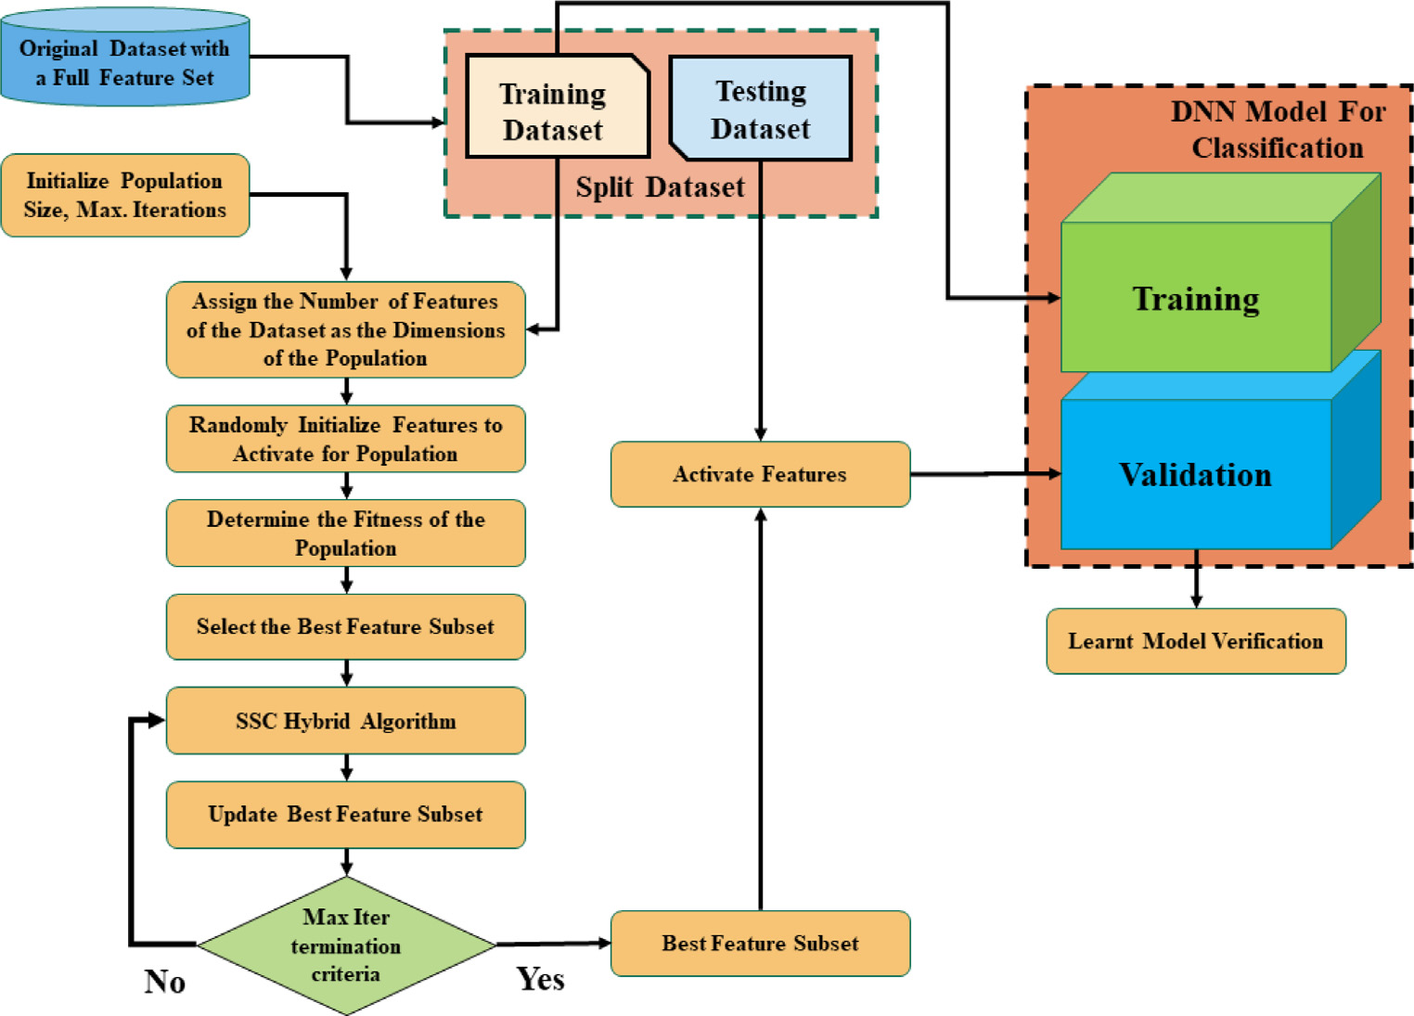

**Fig. 9.** Flow diagram of SSC Hybrid Meta-heuristic Algorithm.

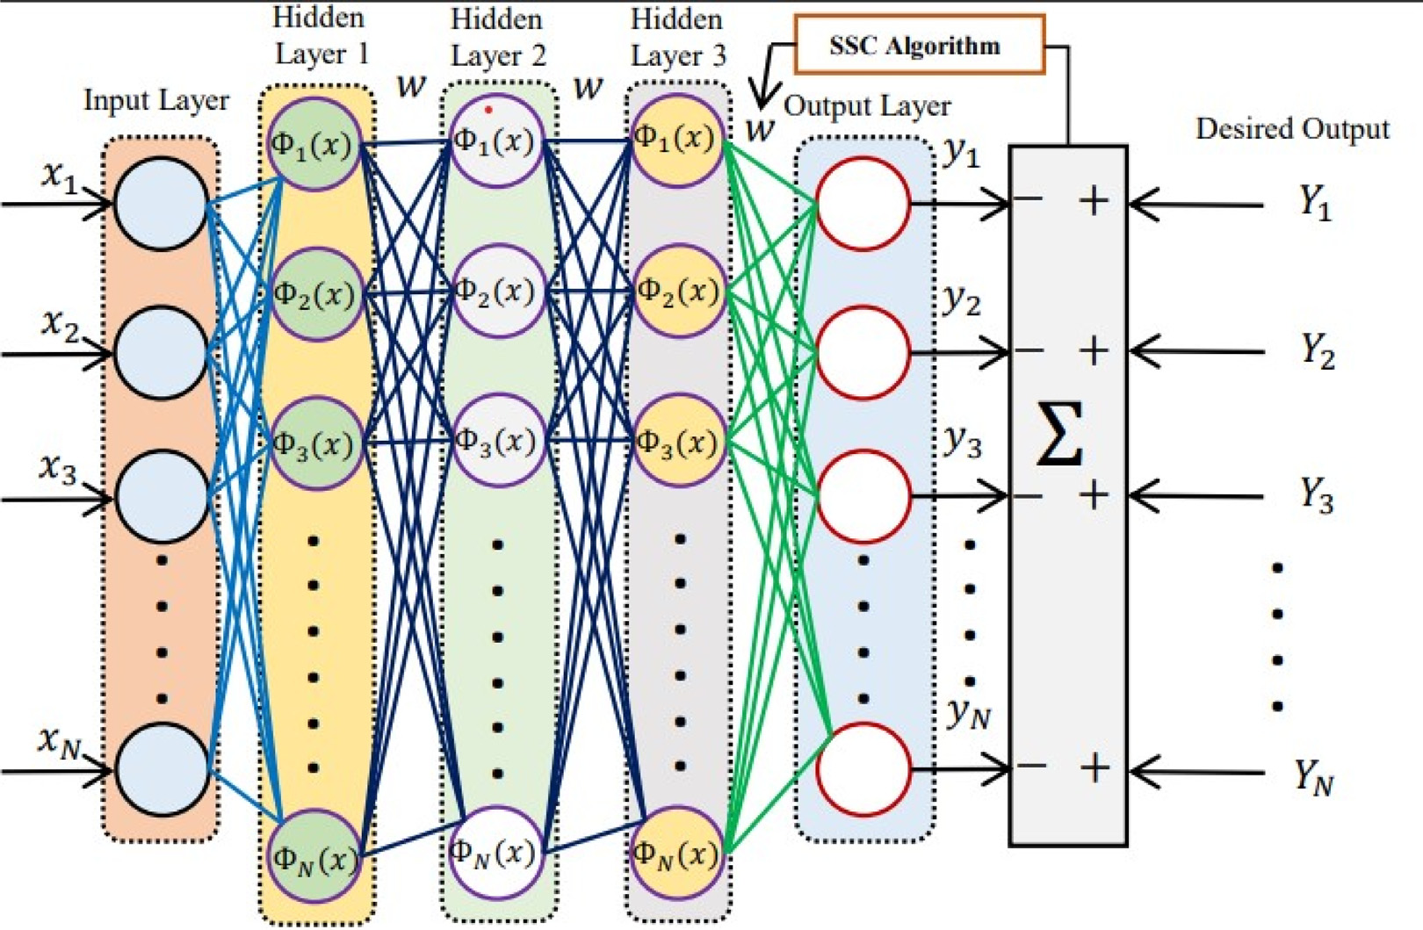

**Fig. 10.** SSC based Three Layer DNN structure for Classification.

*5.3. SSC-based DNN model*

Metaheuristic algorithms have been used in recent years for the training of weights and biases in neural networks. Compared to tra-ditional optimization algorithms such as stochastic gradient descent, metaheuristic algorithms offer several advantages. Firstly, they are less sensitive to initialization and are able to escape local optima more easily, allowing them to explore a larger search space. Secondly, they can handle non-convex and non-smooth optimization problems, which

9

*H. Mohyuddin et al.*  *Array 19 (2023) 100317*

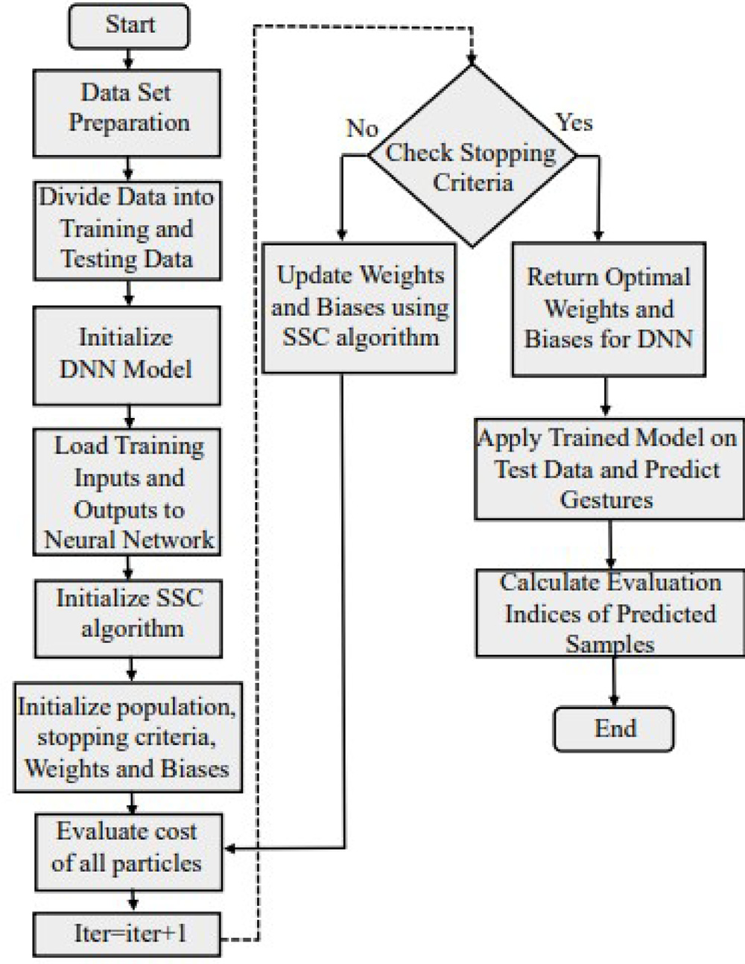

**Fig. 11.** Flow chart of SSC-based Tuning of Weights and Biases of DNN.

improved performance compared to traditional optimization algorithms for neural network training. Therefore in this work, SSC is used for effective tuning of weights and biases of the DNN.

**6. Results**

Results for this paper are recorded for both feature selection and classification algorithms. The feature selection method is compared with conventional metaheuristic algorithms over multiple iterations and different metrics are recorded for each algorithm. Section 6.1 dis-cusses the results of feature selection. In addition, The selected features are then passed through a DNN trained with different metaheuristic algorithms, and the results of the DNN classification are discussed in 6.2.

*6.1. Evaluation of feature selection*

During the experimentation, 30 iterations were performed. The train-test split ratio was set at 0.2 for test set. In each iteration, different train-test data was used. Accuracy, Precision, F1-score, execution time, and total reduced features were recorded for each iteration. Final data was tabulated and average values were tabulated to check the final results. Each algorithm is trained using Random Forest (RF) and SVM optimizer and all metrics are compared for PSO, GWO, SCA, and SSC algorithms. Fig. 12 shows a comparison of average scores for accuracy, precision, F1-score, and no. of features extracted using the feature selection algorithm. Fig. 13 shows the average train time for each tech-nique over 30 different iterations. It is evident that the proposed SSC algorithm has the highest scores among the metaheuristic algorithms whilst recording the lowest average among the features selected. Fig. 14 shows the best results achieved during the 30 iterations, showing a similar pattern, with SSC achieving the highest accuracy, precision,

10

*H. Mohyuddin et al.*  *Array 19 (2023) 100317*

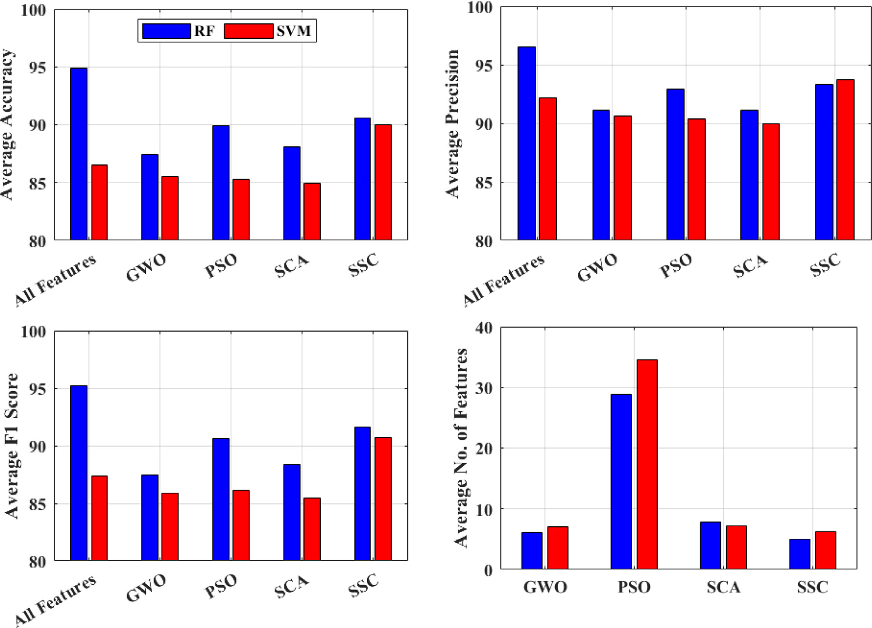

**Fig. 12.** Feature Selection Results: Average Accuracy, Precision, F1-Score, No. of Features.

|  |  |  |  |
| --- | --- | --- | --- |
| **Table 4**  Comparative analysis of feature selection and meta-heuristic algorithms for gesture detection. | | |  |
| Title | Data-set | Technique used | Accuracy |
| [60] | Indian Sign Language(Pictorial 6 static colored images) | Feature selection + NN for classification (trained using hybrid meta-heuristic deer hunting + gwo) | 0.97 |
| [61]  [62]  [63]  [64]  [65]  [64]  [49]  [66]  [15]  Our model | Image Data-set from Kaggle (36 columns)  Spatial Data-set (Arabic Sign Language Numerals 1-9) Image Data-set (Arabic Sign Language, 14 images) Ten Static Images Collected Using LMC  ASL (26 Letters Static)  ISL (26 Letters)  Static Nine gestures  Six Static images  Three static gestures (Rock, paper, scissors)  Eight static gestures | PCA + BPSO for NN training  Radial basis function  KNN/SVM + Ada Boost  FS(using GA) + KNN/RF/NB  SVM + DNN  NB  FS(static; based on Orientation) + SVM classification HOG + SVM (multi-class)  FS (static 11 points) + DNN Classification  Meta-heuristic (SSC) FS + DNN Trained with SSC | 0.98  0.94  0.91  0.74  0.94  0.95  0.91  0.92  0.98  0.98 |

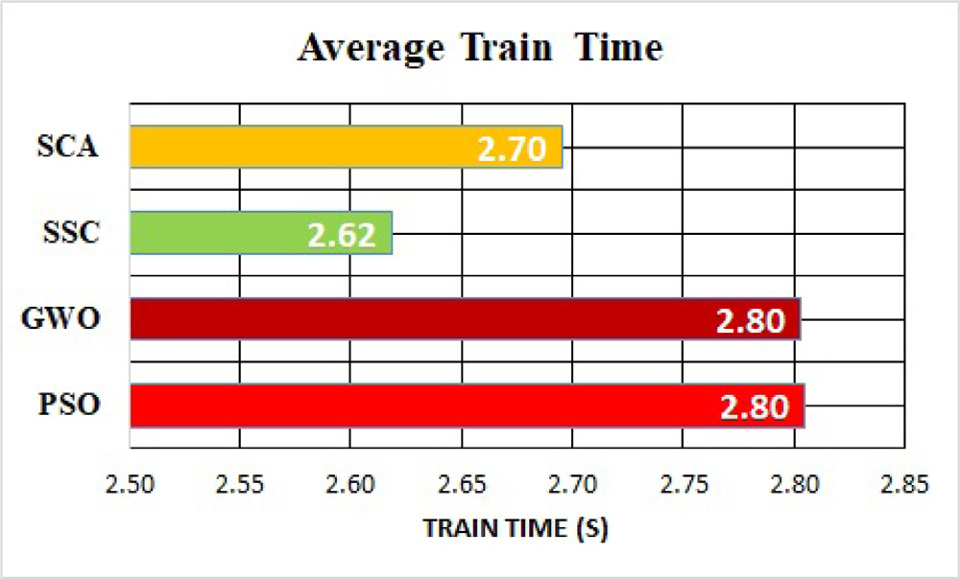

**Fig. 13.** Feature Selection Results: Average Train times over 20 iterations.

11

*H. Mohyuddin et al.*  *Array 19 (2023) 100317*

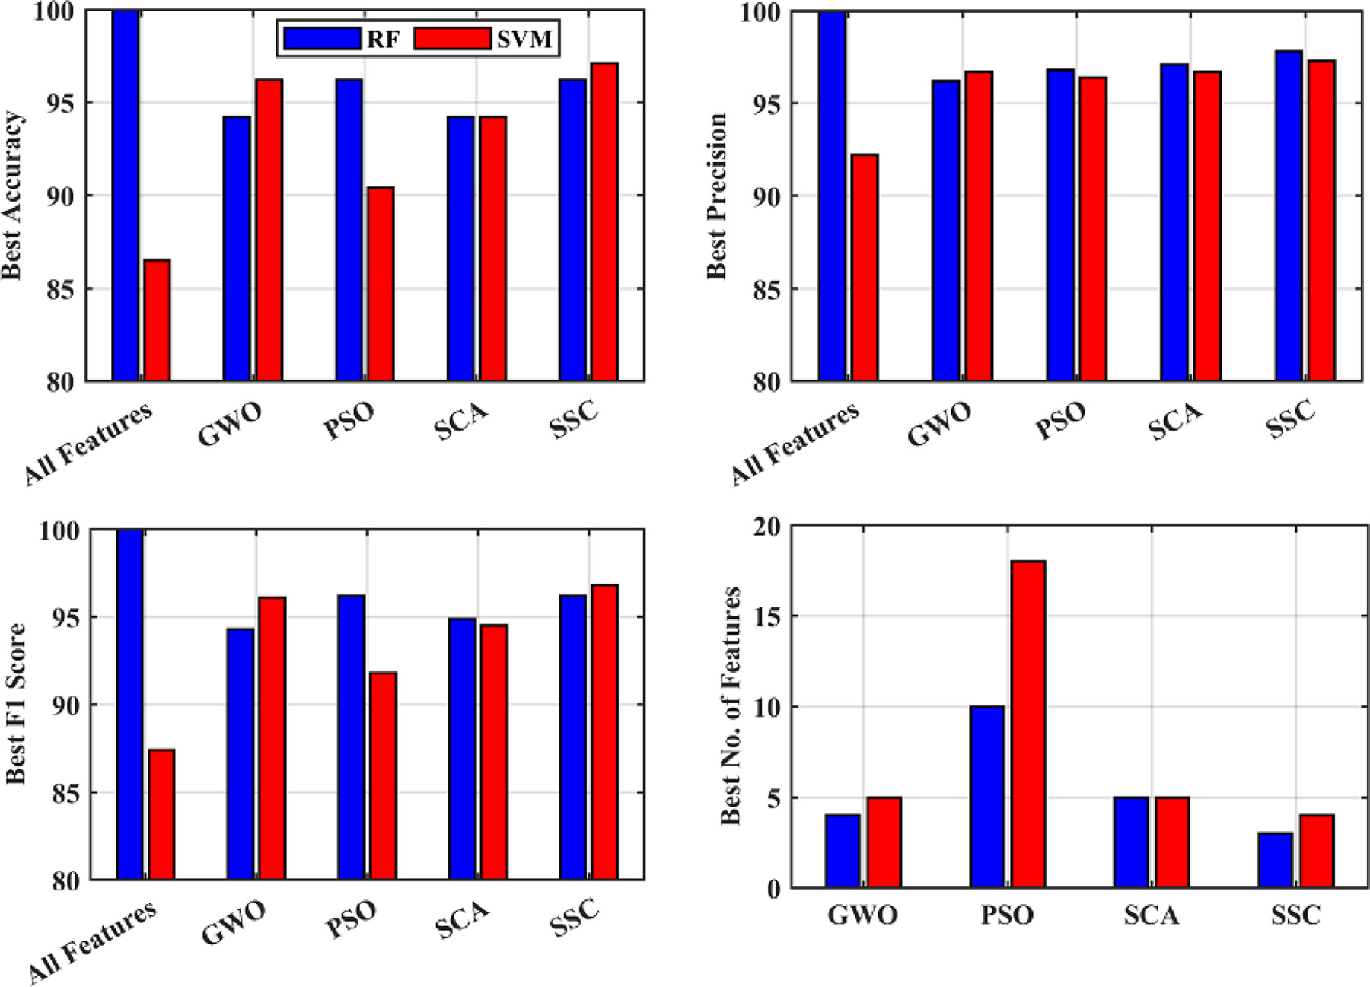

**Fig. 14.** Feature Selection Results: Best Accuracy, Precision, F1-Score, No. of Features.

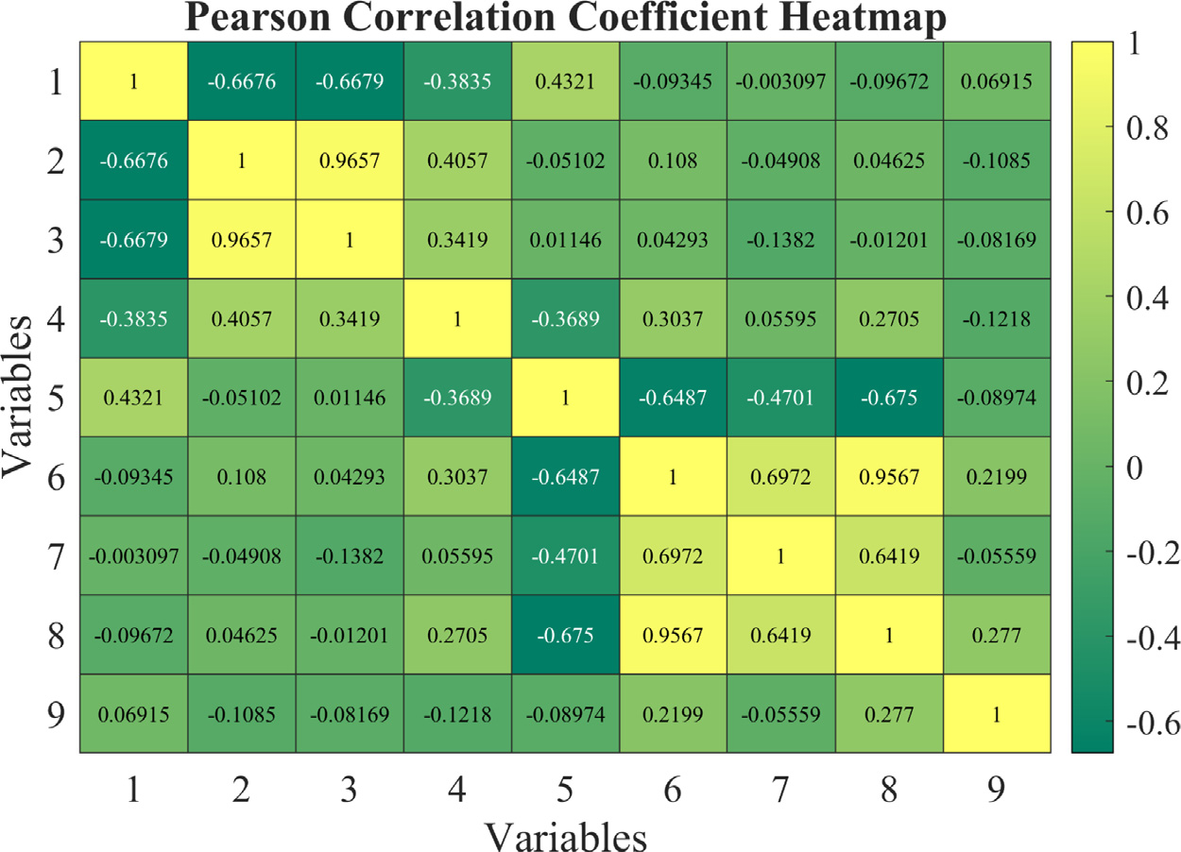

**Fig. 15.** Correlation of Input features and Target variable of the selected data-set.

Furthermore, we extended our research by applying the SSC al-gorithm to train a DNN for gesture classification. The results of our experiments with the DNN trained using SSC surpassed those obtained with other algorithms, achieving an impressive 98.7% accuracy rate. This outstanding performance further reinforces the effectiveness of the SSC algorithm for optimizing the training process of complex machine-learning models.

The findings of this research have important implications for the field of gesture recognition and related applications, such as virtual

12

*H. Mohyuddin et al.*  *Array 19 (2023) 100317*

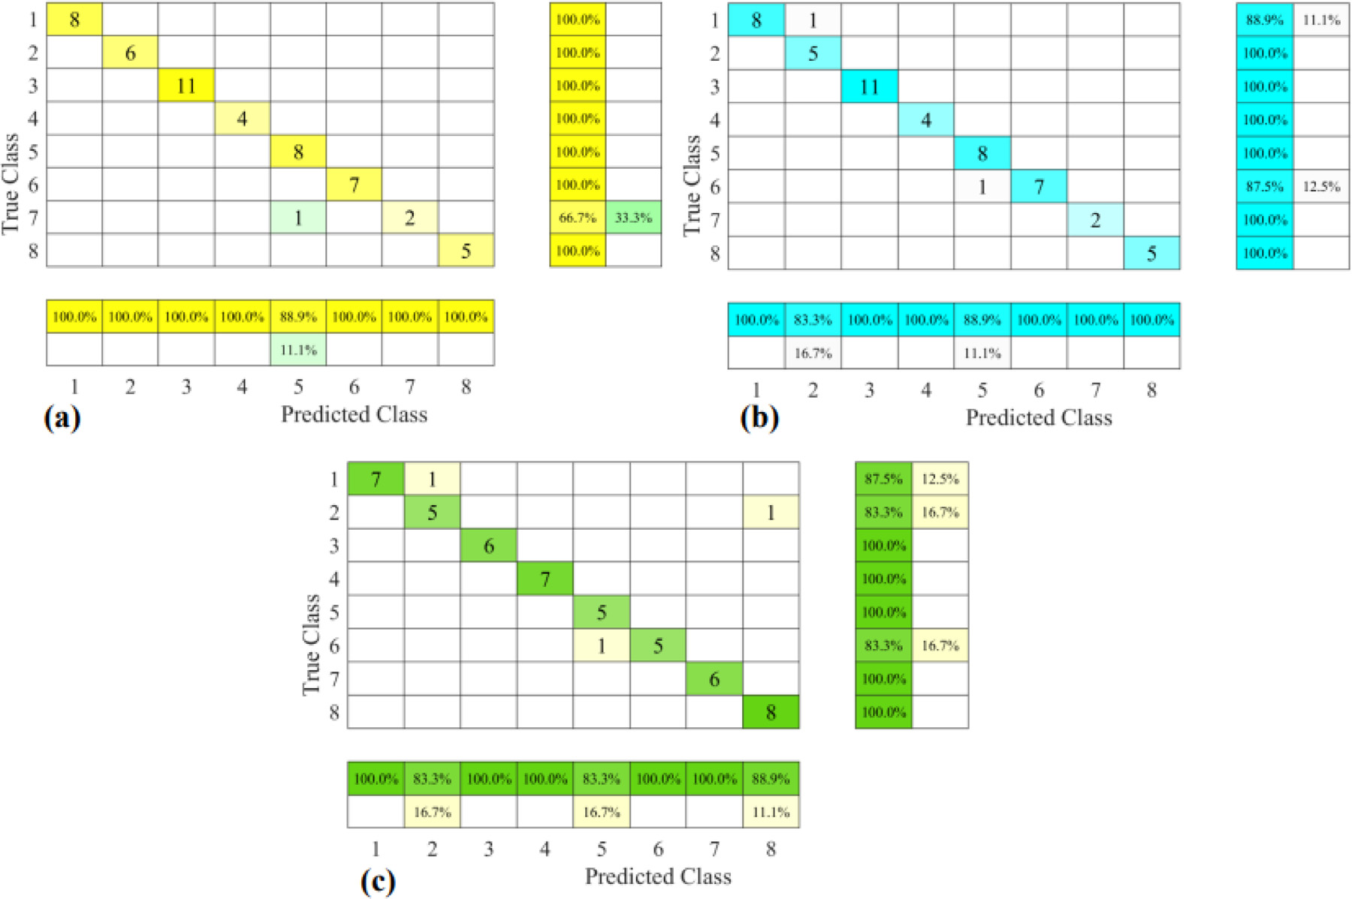

**Fig. 16.** Confusion Matrix of Classification Results with Selected Features.

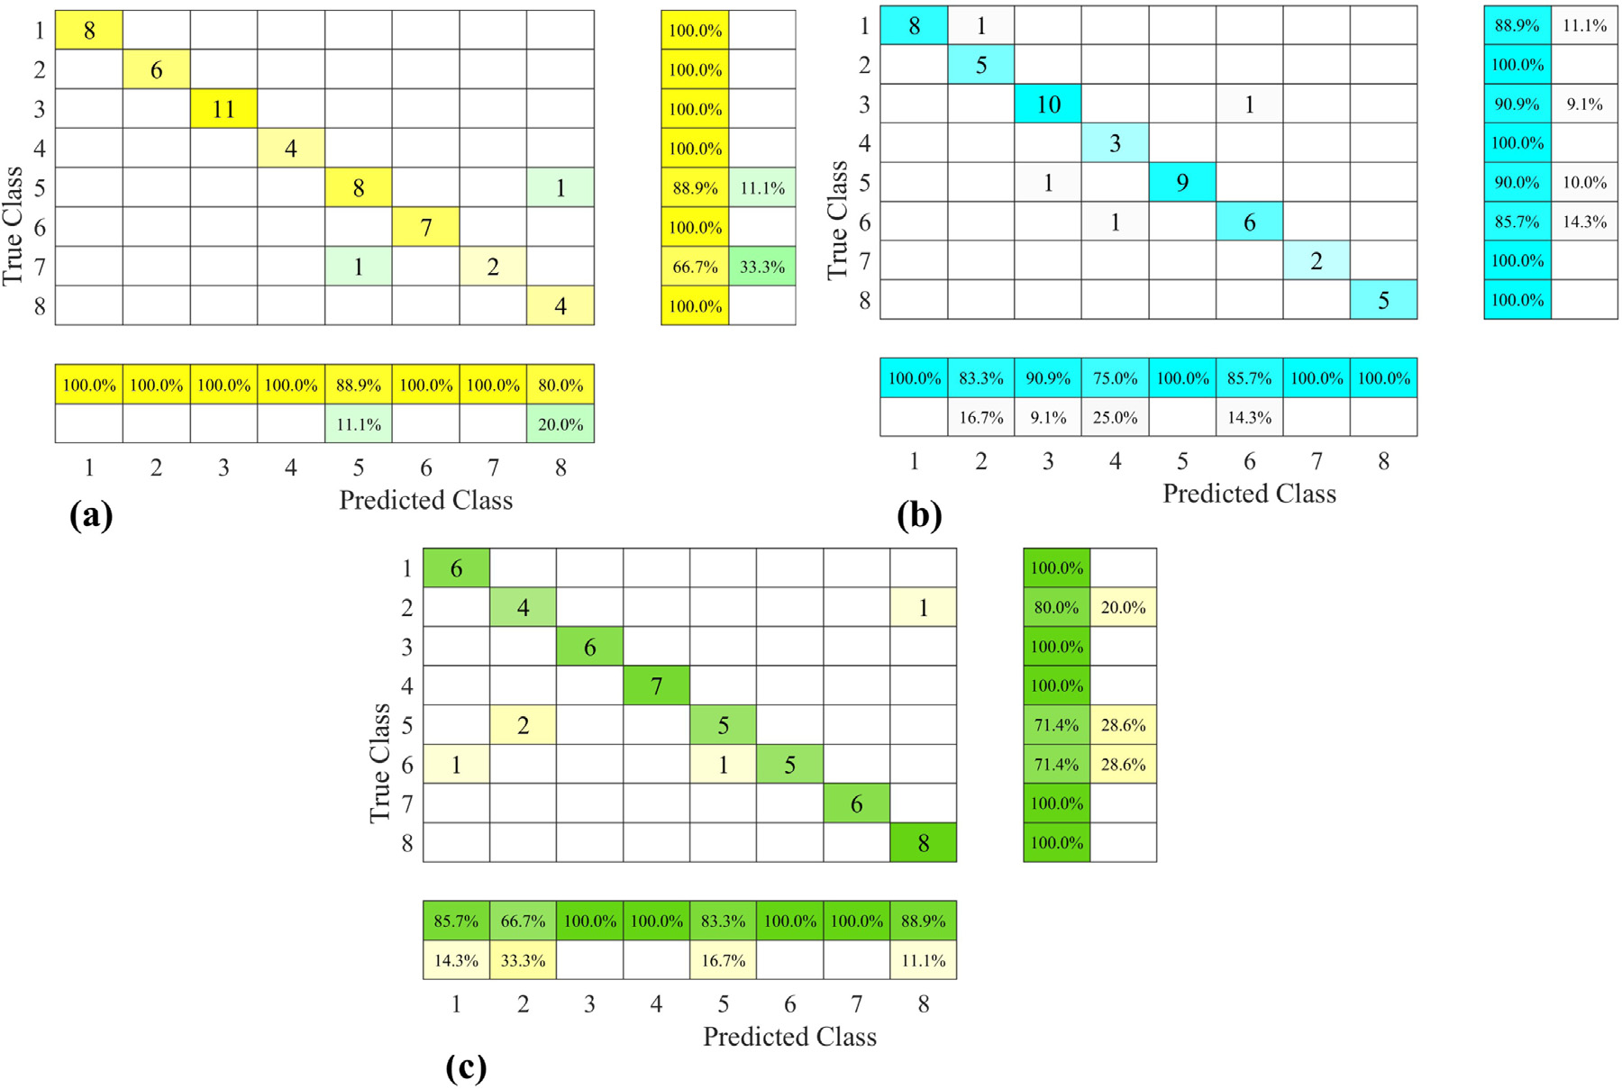

**Fig. 17.** Confusion Matrix of Classification Results with Full Features.

13

*H. Mohyuddin et al.*  *Array 19 (2023) 100317*

dynamic environments could bridge the gap between research and

practical application. These directions hold the potential to elevate

gesture recognition technology’s accuracy and usability

**CRediT authorship contribution statement**

**Hassan Mohyuddin:** Conceptualization, Methodology, Resources,

Project administration, Validation, Data curation, Software, Prepa-

ration and review of the original manuscript. **Syed Kumayl Raza**

**Moosavi:** Conceptualization, Formal analysis, Investigation, Prepara-

tion and review of the original manuscript. **Muhammad Hamza Zafar:**

Visualization, Data curation, Validation, Formal analysis, Preparation

and review of the original manuscript. **Filippo Sanfilippo:** Supervision,

Funding, acquisition, Investigation, Preparation and review of the

original manuscript.

**Declaration of competing interest**

NONE.

All authors claim that there is not any conflict of interest regard-

ing the above submission. The work of this submission has not been

published previously. It is not under consideration for publication else-

where. Its publication is approved by all authors and that, if accepted,

it will not be published elsewhere in the same form, in English or in any

other language, including electronically without the written consent of

the copyright-holder.

**Data availability**

Data will be made available on request.

**References**

[1] Kambatla K, Kollias G, Kumar V, Grama A. Trends in big data ana-

lytics. J Parallel Distrib Comput 2014;74(7):2561–73. [http://dx.doi.org/10.](http://dx.doi.org/10.1016/j.jpdc.2014.01.003)

[1016/j.jpdc.2014.01.003](http://dx.doi.org/10.1016/j.jpdc.2014.01.003), URL [https://www.sciencedirect.com/science/article/](https://www.sciencedirect.com/science/article/pii/S0743731514000057)

[pii/S0743731514000057](http://dx.doi.org/10.1016/j.jpdc.2014.01.003). Speci[al](https://www.sciencedirect.com/science/article/pii/S0743731514000057)  [Issue](https://www.sciencedirect.com/science/article/pii/S0743731514000057)  [on](https://www.sciencedirect.com/science/article/pii/S0743731514000057)  [Perspectives](https://www.sciencedirect.com/science/article/pii/S0743731514000057)  [on](https://www.sciencedirect.com/science/article/pii/S0743731514000057)  [Parallel](https://www.sciencedirect.com/science/article/pii/S0743731514000057)  [and](https://www.sciencedirect.com/science/article/pii/S0743731514000057)

[Distributed Processing.](https://www.sciencedirect.com/science/article/pii/S0743731514000057)

[2] [Russom P, et al. Big data analytics. TDWI Best Pract Rep 2011;19(4):1–34.](http://refhub.elsevier.com/S2590-0056(23)00042-5/sb2)

[3] [Madden S. From databases to big data. IEEE Internet Comput 2012;16(3):](http://refhub.elsevier.com/S2590-0056(23)00042-5/sb2)4–6.

<http://dx.doi.org/10.1109/MIC.2012.50>.

[4] [Singh D, Reddy CK. A survey on platf](http://dx.doi.org/10.1109/MIC.2012.50)orms for big data analytics. J Big Data

2014;2(1):8. <http://dx.doi.org/10.1186/s40537-014-0008-6>.

[5] Wang RY, S[trong DM. Beyond accuracy: What data qu](http://dx.doi.org/10.1186/s40537-014-0008-6)ality means to data

consumers. J Manage Inf Syst 1996;12(4):5–33. [http://dx.doi.org/10.1080/](http://dx.doi.org/10.1080/07421222.1996.11518099)

[07421222.1996.11518099](http://dx.doi.org/10.1080/07421222.1996.11518099).

[6] [Samitsch C. Introduction. Wiesbaden: Springer Fachmedien Wiesbaden; 2015, p.](http://refhub.elsevier.com/S2590-0056(23)00042-5/sb6)

[1–3.](http://refhub.elsevier.com/S2590-0056(23)00042-5/sb6)

[7] [Obermeyer Z, Emanuel EJ. Predicting the future-big data, machine learning, and](http://refhub.elsevier.com/S2590-0056(23)00042-5/sb7)

[clinical medicine. N Engl J Med 2016;375(13):1216–9.](http://refhub.elsevier.com/S2590-0056(23)00042-5/sb7)

[8] [Sun Y, Shi Y, Zhang Z. Finance big data: Management, a](http://refhub.elsevier.com/S2590-0056(23)00042-5/sb7)nalysis, and applications.

Int J Electron Commer 2019;23(1):9–11. [http://dx.doi.org/10.1080/10864415.](http://dx.doi.org/10.1080/10864415.2018.1512270)

[2018.1512270](http://dx.doi.org/10.1080/10864415.2018.1512270).

[9] [Hassanpour R, Wong S, Shahbahrami A. Visionbased hand gesture recognition](http://refhub.elsevier.com/S2590-0056(23)00042-5/sb9)

[for human computer interaction: A review. In: IADIS international conference](http://refhub.elsevier.com/S2590-0056(23)00042-5/sb9)

[interfaces and human computer interaction, Vol. 125. Citeseer; 2008.](http://refhub.elsevier.com/S2590-0056(23)00042-5/sb9)

[10] [Metcalf CD, Robinson R, Malpass AJ, Bogle TP, Dell TA, Harris C, D](http://refhub.elsevier.com/S2590-0056(23)00042-5/sb9)[emain SH.](http://refhub.elsevier.com/S2590-0056(23)00042-5/sb10)

[Markerless motion capture and measurement of hand kinematics: validation and](http://refhub.elsevier.com/S2590-0056(23)00042-5/sb10)

[application to home-based upper limb rehabilitation. IEEE Trans Biomed Eng](http://refhub.elsevier.com/S2590-0056(23)00042-5/sb10)

[2013;60(8):2184–92.](http://refhub.elsevier.com/S2590-0056(23)00042-5/sb10)

[11] [Wu C, Shahabi C. Vision-based hand gesture recognition for human-vehicle](http://refhub.elsevier.com/S2590-0056(23)00042-5/sb11)

[interaction: A review. IEEE Trans Intell Transp Syst 2018;20(4):1437–55.](http://refhub.elsevier.com/S2590-0056(23)00042-5/sb11)

[12] [Toalumbo B, Nogales R. Hand gesture recognition using leap motion con](http://refhub.elsevier.com/S2590-0056(23)00042-5/sb11)[troller,](http://refhub.elsevier.com/S2590-0056(23)00042-5/sb12)

[infrared information, and deep learning framework. 2022, p. 412–26.](http://refhub.elsevier.com/S2590-0056(23)00042-5/sb12)

[13] [Ke Q, Liu J, Bennamoun M, An S, Sohel F, Boussaid F. Chapter](http://refhub.elsevier.com/S2590-0056(23)00042-5/sb12) 5 - com-

puter vision for human–machine interaction. In: Leo M, Farinella GM, editors.

Computer vision for assistive healthcare. Computer vision and pattern recog-

nition, Academic Press; 2018, p. 127–45. [http://dx.doi.org/10.1016/B978-0-](http://dx.doi.org/10.1016/B978-0-12-813445-0.00005-8)

[12-813445-0.00005-8](http://dx.doi.org/10.1016/B978-0-12-813445-0.00005-8), URL [https://www.sci](https://www.sciencedirect.com/science/article/pii/B9780128134450000058)[encedirect.com/science/article/pii/](http://dx.doi.org/10.1016/B978-0-12-813445-0.00005-8)

[B97801281344500000](http://dx.doi.org/10.1016/B978-0-12-813445-0.00005-8)[58](https://www.sciencedirect.com/science/article/pii/B9780128134450000058).

14

*H. Mohyuddin et al.*  *Array 19 (2023) 100317*

[43] [Kammer D, Wojdziak J, Keck M, Groh R, Taranko S. Towards a formalization of multi-touch gestures. In: ACM international conference on interactive tabletops and surfaces. 2010, p. 49–58.](http://refhub.elsevier.com/S2590-0056(23)00042-5/sb43)

[44] [Sharma JK, Gupta R, Pathak](http://refhub.elsevier.com/S2590-0056(23)00042-5/sb43) VK. Numeral gesture recognition using leap motion sensor. In: 2015 international conference on computational intelligence and communication networks (CICN). 2015, p. 411–4. [http://dx.doi.org/10.1109/ CICN.2015.86](http://dx.doi.org/10.1109/CICN.2015.86).

[45] Vaitkevičius A, Taroza M, Blažauskas T, Damaševičius R, Maskeli¯unas R, Woź-niak M. Recognition of American sign language gestures in a virtual reality using leap motion. Appl Sci 2019;9(3). <http://dx.doi.org/10.3390/app9030445>, URL <https://www.mdpi.com/2076-3417/9/3/445>[.](http://dx.doi.org/10.3390/app9030445)

[46] [Yao Y, Fu Y. Contour model-based hand-g](https://www.mdpi.com/2076-3417/9/3/445)esture recognition using the kinect sensor. IEEE Trans Circuits Syst Video Technol 2014;24(11):1935–44. [http://dx. doi.org/10.1109/TCSVT.2014.2302538](http://dx.doi.org/10.1109/TCSVT.2014.2302538).

[47] [Zeng W, Wang C, Wang Q. Hand ge](http://dx.doi.org/10.1109/TCSVT.2014.2302538)[sture recognition using leap motion via](http://refhub.elsevier.com/S2590-0056(23)00042-5/sb47)  [deterministic learning. Multimed Tools Appl 2018;77:28185–206.](http://refhub.elsevier.com/S2590-0056(23)00042-5/sb47)

[48] [Lu W, Tong Z, Chu J. Dynamic hand gesture recognition wit](http://refhub.elsevier.com/S2590-0056(23)00042-5/sb47)h leap motion controller. IEEE Signal Process Lett 2016;23(9):1188–92. [http://dx.doi.org/10. 1109/LSP.2016.2590470](http://dx.doi.org/10.1109/LSP.2016.2590470).

[49] [Xu Y, Wang Q, Bai X, C](http://dx.doi.org/10.1109/LSP.2016.2590470)hen Y-L, Wu X. A novel feature extracting method for dynamic gesture recognition based on support vector machine. In: 2014 IEEE international conference on information and automation (ICIA). 2014, p. 437–41. <http://dx.doi.org/10.1109/ICInfA.2014.6932695>.

[50] [Xue B, Zhang M, Browne WN, Yao X. A surve](http://dx.doi.org/10.1109/ICInfA.2014.6932695)[y on evolutionary computation](http://refhub.elsevier.com/S2590-0056(23)00042-5/sb50)  [approaches to feature selection. IEEE Trans Evol Comput 2015;20(4):606–26.](http://refhub.elsevier.com/S2590-0056(23)00042-5/sb50) [51] [Akinola OO, Ezugwu AE, Agushaka JO, Zitar RA, Abualigah L. Multiclass featu](http://refhub.elsevier.com/S2590-0056(23)00042-5/sb50)[re](http://refhub.elsevier.com/S2590-0056(23)00042-5/sb51)  [selection with metaheuristic optimization algorithms: a review. Neural Comput](http://refhub.elsevier.com/S2590-0056(23)00042-5/sb51)  [Appl 2022;34(22):19751–90.](http://refhub.elsevier.com/S2590-0056(23)00042-5/sb51)

[52] [Chen L, Liu Y, Liu X. Gestu](http://refhub.elsevier.com/S2590-0056(23)00042-5/sb51)[re recognition based on improved particle swarm optimization feature selection and improved support vector machine. In: Pro-ceedings of the 2013 IEEE international conference on robotics and automation (ICRA). 2013, p. 2201–6.](http://refhub.elsevier.com/S2590-0056(23)00042-5/sb52)

[53] [Wang J, Khishe M, Kave](http://refhub.elsevier.com/S2590-0056(23)00042-5/sb52)[h M, Mohammadi H. Binary chimp optimization algo-rithm (BChOA): a new binary meta-heuristic for solving optimization problems. Cogn Comput 2021;13:1297–316.](http://refhub.elsevier.com/S2590-0056(23)00042-5/sb53)

[54] [Sayed GI, Tharwat A, Hassanien](http://refhub.elsevier.com/S2590-0056(23)00042-5/sb53) [AE. Chaotic dragonfly algorithm: an improved](http://refhub.elsevier.com/S2590-0056(23)00042-5/sb54)  [metaheuristic algorithm for feature selection. Appl Intell 2019;49:188–205.](http://refhub.elsevier.com/S2590-0056(23)00042-5/sb54)

15